Installing minikube

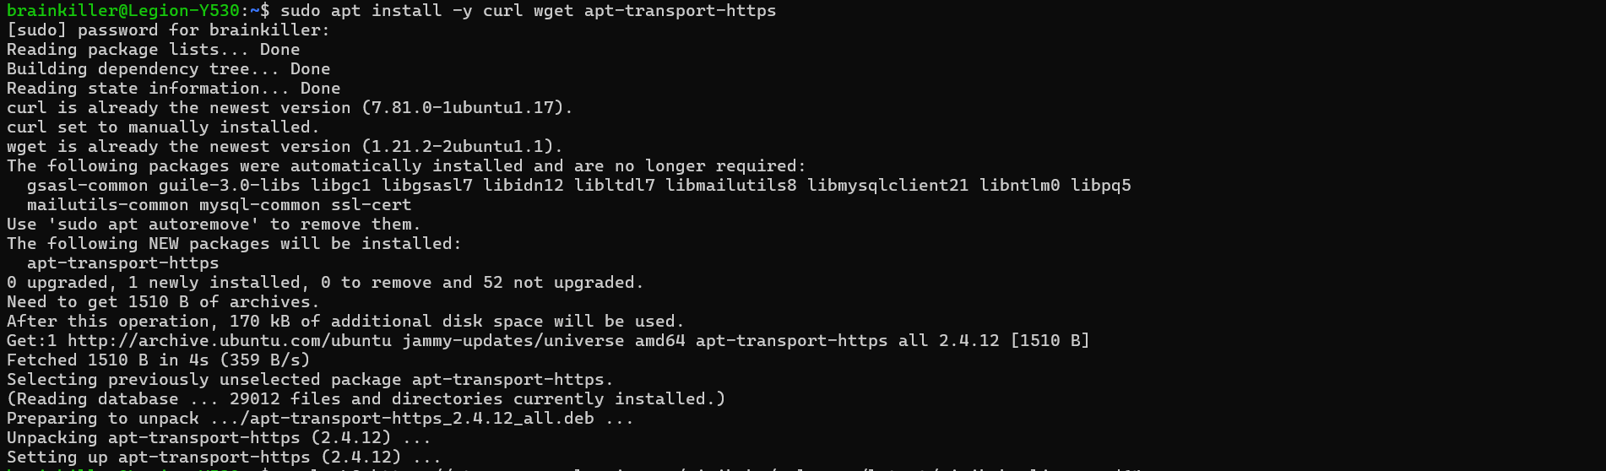



Initiating the minikube:



Installing kubectl:  
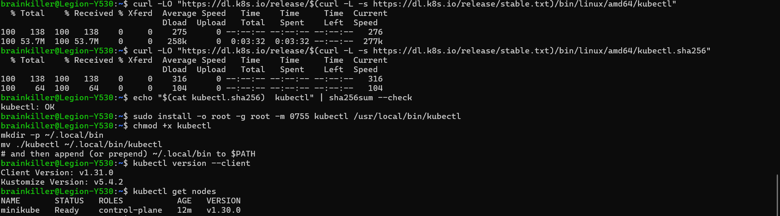

Namespaces

